



MINISTRY OF EDUCATION
STATE DEPARTMENT FOR TECHNICAL VOCATIONAL EDUCATION AND TRAINING

BUNGOMA NORTH TECHNICAL AND VOCATIONAL COLLEGE
P.O. BOX 72 —50211, NAITIRI TEL: 0740437371 / 0746825713

Email: info@bungomanorthtvc.ac.ke Website: www.bungomanorthtvc.ac.ke
Our Reference: BNTVC/QMS/REG/F07 Date: 01/10/2025

LETTER OF OFFER

Dear; …………………………………………………………………………………………….
I am pleased to inform you that you have been offered a chance to study in a course leading to:
…………………………………………………………………………………………..
You are expected to report on 05/01/2026
Note that failure to report by 16/01/2026 deadline you will automatically be considered to have deferred/forfeited your chance till the next available intake on condition that you apply afresh.
Please bring the following items on admission day:
- This letter of offer with dully signed medical form section.
- Original academic certificates /result slips, birth certificate, KRA pin, National ID and two photocopies of each.
- One ream of photocopying papers and two spring files.
- Banking slip of full 1st instalment fee payable to BUNGOMA NORTH TECHNICAL AND VOCATIONAL COLLEGE, KCB BANK KIMILILIBRANCH, ACCOUNT NO. 1271255235
VII. Two recently taken colored passport size photographs
NOTE:
- SPONSORSHIP, BURSARIES or any FINANCIAL ASSISTANCE IS NOT GUARANTEED by the
College upon intake or during the entire period of study.
- For those who are sponsored, proof of sponsorship MUST be produced before registration/admission.
- You must always retain any cash office receipts in case of any future queries regarding payment of fees.
- On reporting collect your registration form from the Registry clerk in the Registrar’s office who will check your certificates and other registration items before directing you to the finance office to submit your M-PESA message /Bank deposit Slips.
NOTE THAT WE DO NOT ACCEPT ANY CASH PAYMENTS!
- This offer does not include Hostel /Accommodation fee and meals.
- Attached to this letter of offer are fee structure, materials and equipment’s that MUST be purchased by the student in line with your course requirements.
- Attached is a medical examination certificate that MUST be submitted dully completed signed and stamped by a recognized and registered medical doctor.
All correspondences should be addressed to:
The Principal
Bungoma North Technical & Vocational College,
P.O. Box 72 -50211. NAITIRI
Looking forward to your successful study
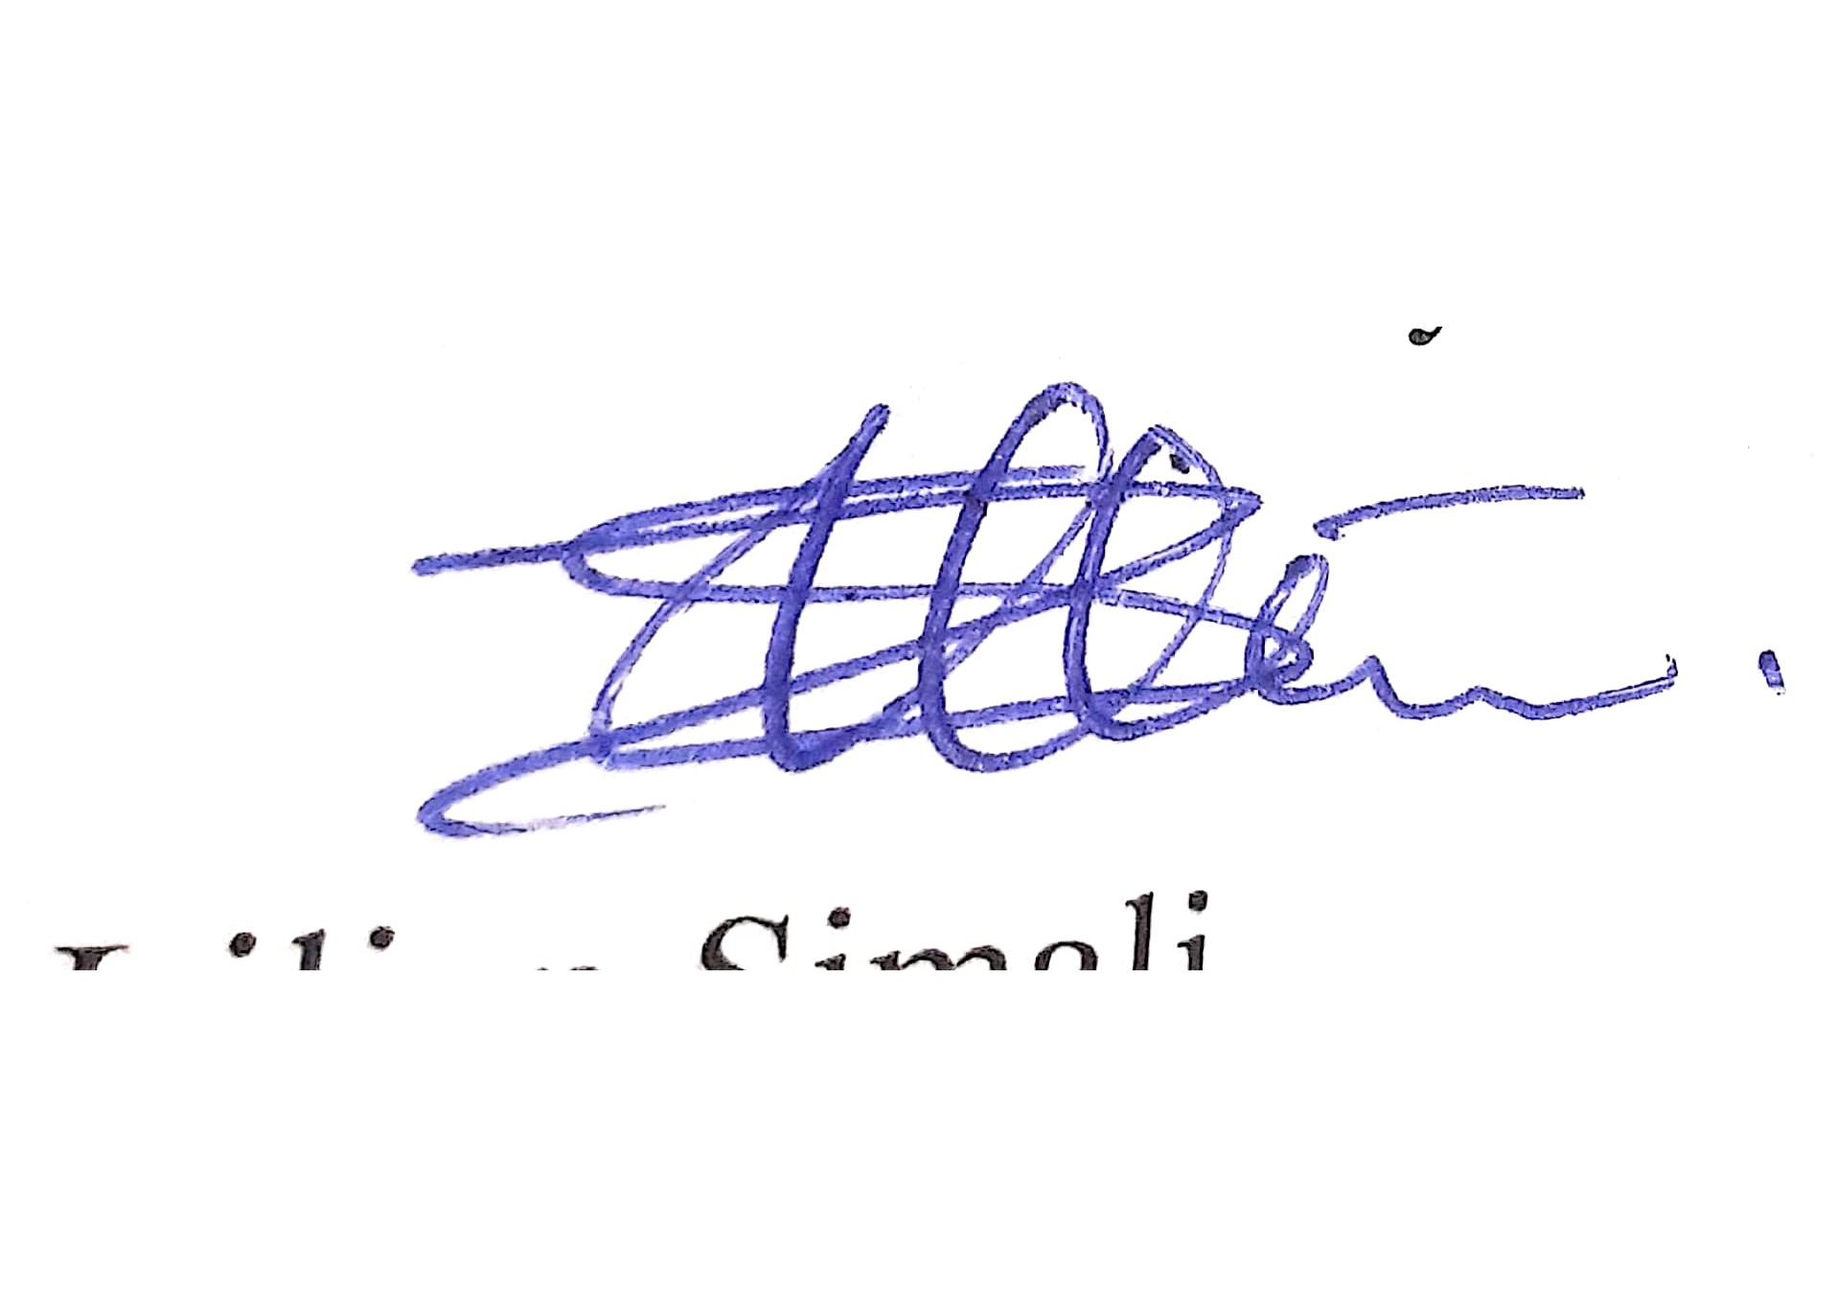
Yours faithfully,


Ms. Lilian Simali
PRINCIPAL/ BOG SECRETARY

APPROVED TVET FEES CHARGEABLE F.Y 2025-2026
TOTAL FEES OBLIGATION
VOTEHEADS | TERM ONE  (KSHS) | TERM TWO (KSHS) | TERM THREE(KSHS)
MATERIAL | 9,600 | 9,600 | 9,600
ASSESSMENT TOOLS | 3000 | 3000 | 3000
TUITION | 8400 | 8400 | 8400
P.E | 4,500 | 4,500 | 4,500
E.W& C | 900 | 900 | 900
R.M.I | 1500 | 1500 | 1500
LTT | 2200 | 2200 | 2200
MEDICAL | 400 | 400 | 400
LIBRARY | 900 | 900 | 900
ACTIVITY | 770 | 770 | 770
ADMIN | 2830 | 2830 | 2830
TOTAL | 35,000 | 35,000 | 35,000
Admission Instructions:
1. Each Trainee on Admission Shall pay a total of Kshs. 3,050. Breakdown is given as below:
S/No | ITEM DESCRIPTION | AMOUNT (KSHS)
1 | KUCCPS Placement Fee - paid once | 500
2 | School ID Card fee – paid once | 500
3 | Admission fee | 500
4 | TVETA Audit Fee– paid once | 500
5 | Student union fee paid annually | 1,050
2. External Examination Fees Shall be paid as guided by Examination Bodies.
3. Trainees sitting for external Exams MUST clear fee before exam registration
4. All fees should be banked on the college Bank AND/OR Through Paybill No. 522123 Account NO. 59228K/Adm no.
5. No Cash Money Transactions are accepted.
S/No | Bank Account number | Bank Account Name | Branch
1 | 1271255235 | Bungoma North Technical College | KCB- KIMILILI
All Trainees to visit HELB AND KUCCPS Desk

BUNGOMA NORTH TECHNICAL AND VOCATIONAL COLLEGE

NEW FUNDING MODEL FOR THE FINANCIAL YEAR 2025/2026

Need level | Scholarship  % | Amount | Helb Loan % | Amount | Total Helb loan & Scholarship | Household (parent/ guardian) | Amount | Upkeep
Band 1  Vulnerable | 70% | 47,032 | 22.5% | 15118 | 62,150 | 7.5% | 5,039 | 18,600
Band 2  Extremely needy | 60% | 40,313 | 28% | 18,813 | 59,126 | 12% | 8063 | 17,600
Band 3  Needy | 50% | 33,595 | 32% | 21,500 | 55,096 | 18% | 12,094 | 15,600
Band 4  Less needy | 40% | 26,876 | 38% | 25,532 | 52,408 | 22% | 14,781 | 14,600
Band 5  Able to apply | 30% | 20,157 | 43% | 28,891 | 49,048 | 27% | 18,141 | 13,600
Self sponsored/private student | 0 | 0 | 0 | 0 | 0

All students will be funded depending on their levels.

REQUIREMENTS FOR ELEGIBILITY FOR NEW FUNDING MODEL
a. Valid email address
- Valid telephone number (must be registered by your name)
- KCPE and KCSE index numbers and their years
- Passport size photo
- Copy of national ID
- College admission letter
- Parent’s registered phone number
- Birth certificate
- Death certificate, if any, of deceased parent
- Two guarantors (can be parents) ID numbers and registered phone numbers
- Copy of sponsorship letter if you were sponsored in secondary school

NOTE
Following your placement in this college, you are eligible for a government Scholarship, Loan and Bursary to assist with your education expenses. If you need Government financial support, you MUST make an application for consideration through the official website:
www.hef.co.ke . In case the Government scholarship, loan and bursary do not cover the entire cost of your programme, the deficit will be met by your parent/guardian.

The Following are Mandatory Departmental Requirements:

FASHION & DESIGN  - Dust coat (white)  - Tape measure.  - Tailors pin.  - Tailors chalk.  - Fabric/material.  - Paper scissors.  - Fabric scissors.  - Office glue.  - Seam reaper.  - Thimble.  - Machine needle size 18 flat.  - Hand needles.  - Threads (different colors to match fabric color).  - Tracing wheel.  - Manilla papers.  - 30-cm ruler.  - 1-meter ruler.  - Box file.  - French curve (curve set).  - HB Pencils.  - Needle holder (Manual Singer)  - Bobbin + case (Metallic Manual Singer ) | AGRICULTURE  - Gumboots  - Jembe  - Panga/Slasher  - Dust Coat [Dark Green in Color]  - 1. Scientific calculator  - 1 pair of Gloves  7.1 pair of Agricultural  Mask  Electrical and electronics engineering  1. Screw driver(flat & star)  2. Electrician pliers  3. Dust coat (navy blue)  4. Helmet  5. Spirit level  6. Claw hammer  7. Safety boots  8. Tape measure  9. Phase tester  10. Hack saw  11. Bending spring | COMPUTING AND INFORMATICS  - White Dust coats  - 1. Scientific calculator (Business)  - 2 CD RW  - 8GB & above Flash Disk  - Enough A4 note books  6. Adjustable antistatic ESD wristband (ICT)  7. Screw driver(Philips screw, flat head), pliers(1) and tester(1)  Mech-Auto-Agricultural Engineering  1. Overall or Dust Coat (Navy Blue)  - Engineering Boots  BUSINESS & LIBERAL STUDIES  1. Dust coat (white) | COSMETOLOGY  1. Apron 1 (purple)  2. Towels 4 (medium size)  3. Shampoo 1 litre  4. Styling pins 1 set  5. Scissor 1 pair  6. Braids 5 pieces (black)  7. Afro-comb 1  8. Face towels 2 (white)  9. Manicure set  10. Make-up set  BUILDING & CIVIL ENGINEERING  - Overall/dust coat(navy blue)  - Engineering boots  - Trowel  - Helmet  - Tape measure  - Plumb bob  - Gloves

MINISTRY OF EDUCATION
STATE DEPARTMENT FOR TECHNICAL VOCATIONAL EDUCATION AND TRAINING

BUNGOMA NORTH TECHNICAL AND VOCATIONAL COLLEGE
P.O. BOX 72 —50211, NAITIRI TEL: 0740437371 / 0746825713
Email: info@bungomanorthtvc.ac.ke Website: www.bungomanorthtvc.ac.ke

MEDICAL EXAMINATION CERTIFICATE

NOTE: Applicants for entry to the college must get this form completed by registered
Doctor. PAYMENTS FOR EXAMINATION & TREATMENT ARE THE RESPONSIBILITY OF THE APPLICANT.
NAME: _________________________________ COUNTY: _____________________
1. | Eye and vision:  Unaided right – left?  Aided right - left?  Colour blind  Visual field
2. | Nose & Throat:  Is nasal breathing habitual?  Adenoids?
3. | Ears:  Hearing voice – right?  Left?
4. | Mouth & teeth
5. | Glands in the neck
6. | Chest – Heart  With special reference to any tubercular cadencies.
7. | Spinal cord
8. | - Urine  - Feces
9. | Spleen- Liver  Files & Varicose veins.
10. | Any special weakness, defect or disease e.g. Defects of speech, local witching or spasms or other nervous disorder.Veneral disease or rheumatic Tendency.
11. | General observations. If special care is desirable in any special direction, please give particulars.
HOSPITAL
Please note that the medical fee paid to the institute covers for the cost of drugs at the institute’s dispensary . The fees do not cover hospital treatment

All correspondence to be addressed to the principal

MINISTRY OF EDUCATION
STATE DEPARTMENT FOR TECHNICAL VOCATIONAL EDUCATION AND TRAINING

BUNGOMA NORTH TECHNICAL AND VOCATIONAL COLLEGE
P.O. BOX 72 —50211, NAITIRI TEL: 0740437371 / 0746825713

Email: info@bungomanorthtvc.ac.ke Website: www.bungomanorthtvc.ac.ke

RULES AND REGULATIONS GOVERNING THE CONDUCT AND DISCIPLINE OF TRAINEES.

Preamble
- These rules and regulations are meant to bring order and harmony in the college and make the life and stay of trainees enjoyable. They are meant to enable the college function effectively for ALL its trainees, staff, residents and the community. Trainees are required to sign the form in appendix 1 to confirm that they have read and understood, and will abide by the rules and regulations as stipulated.
- We consider our trainees to be mature and responsible adults who have sense of maturity. Decent behaviour, decent dressing, commitment to work, respect to self and to others and obedience to authority are to be displayed by all without supervision. However, minority of trainees may lack these traits and may need to be guided along a set of rules.
- All trainees must obey, respect and follow instructions from members of staff. iv. These rules and regulation are made by the Academic Committee and the college BoG in accordance with the provisions of the TVET Act whose objective and purpose are among others; to provide for the control governance and administration of the college.
- The Principal as per the Act shall be responsible to the BoG for the general conduct and discipline of the trainees.
- These regulations shall apply to ALL trainees of the college subject to any necessary changes therein. All trainees shall be required to read and abide by these regulations as well as with regulations in general.
- These regulations shall not preclude the college from requiring any student to execute any bond, assurance or undertaking to be of good conduct throughout his/her stay at the Institute.
- Such bond, assurance or undertaking when required and executed shall have the same effect as if it were part of these regulations.

The Conduct of Trainees
The following provisions shall apply with respect to the conduct of trainees within and outside the college precincts.

General Conduct
- Respect and adhere to the administrative and academic rules, procedures and structures established by the TVET Act 29 of 2013.
- Respect the rights and privileges of the members of the college community at all times.
- Refrain from any conduct that might bring the college or any section or programme thereof into disrepute or public odium.
- Carry themselves in all public places or forum with such humility and dignity as befits their status as mature and responsible citizens.
- Wear acceptable and appropriate attire as prescribed in the dress code at all times and in particular while attending lectures, practical sessions or at any other Institute functions. vi. In particular trainees are advised to groom appropriately at all times and should treat their presence in class, laboratories or workshops during training or learning or private study as official functions and present themselves formally with untoward dressing or hairstyle and excessive ornaments.
- All trainees should maintain cleanliness in the college by keeping classrooms and workshops clean and tidy. Litter should not be thrown anyhow except in strategically positioned waste dustbins
- All trainees are encouraged to participate in various games and sports activities during games times. College rules and regulations are to be observed when teams go out to represent the college.
- The College is a DRUGS FREE ZONE. There shall be no tobacco smoking or alcohol drinking or use of illicit drugs within the premises in the college such as Classrooms, Workshops and Drawing rooms.
- Trainees should respect other’s freedom of worship. Where certain religious beliefs and rites conflict with these regulations, the rules of the college shall prevail as long as they do not contradict any laws of the Republic of Kenya.
- Extreme religious inclination such as radicalization is not permitted. xii. Staff washrooms and any other designated area out of bounds to all trainees. xiii. Fighting, use of abusive language, possession of drugs (such as bhang, marijuana, shisha, kuber, mirraa (khat)), changaa, busaa, being drunk and disorderly in the College premises and stealing are prohibited.
Criminal Offences
- The College has no right of exclusive jurisdiction over its trainees in criminal matters and other offences covered by law.
- All crimes and other offences under the laws of Kenya, (THE PENAL CODE CAP 63) shall be reported to police. These shall include the following:
  - Offensive SMS and Cyber crimes ,-Being drunk and disorderly, -Fighting
  - Drug abuse/possession of illegal brew,- Drug trafficking
  - Possessions of dangerous weapons e.g. daggers, arrows, guns etc.
  - Assault causing bodily harm,- Rape or attempted rape
- Arson, attempt to commit arson or attempt to destroy or damage property
  - Theft and other related offences e.g. robbery and extortion
  - Unauthorized picketing, rioting. Obstruction to perform duty
  - Organizing unlawful demonstrations/processions/incitement
  - Kidnapping/abduction, detentions,- Impersonation and false pretenses
  - Sexual harassment, indecent assaults, defilement,- Trespass
  - Forgery, fraud, counterfeiting
  - Illegal/unlicensed trade,- Aiding suicide and attempting suicide
  - Concealing birth, killing of unborn child and abortion
  - Subversion/treason,- Murder, manslaughter
  - Notwithstanding any action that may be taken by the police under the forgoing paragraph, the College may take independent disciplinary measures for both in and outside college.

Enforcement
- These Rules and Regulations Governing the Conduct and Discipline of Trainees are applicable to all trainees registered in the college for all programmes of Study as determined by the Academic Committee.
- All trainees are required to read and sign the Declaration of Undertaking provided with the rules and regulations.

MINISTRY OF EDUCATION

STATE DEPARTMENT FOR TECHNICAL VOCATIONAL EDUCATION AD TRAINING

BUNGOMA NORTH TECHNICAL AND VOCATIONAL COLLEGE
P.O. BOX 72 —50211, NAITIRI TEL: 0740437371 / 0746825713

Email: info@bungomanorthtvc.ac.ke Website: www.bungomanorthtvc.ac.ke

BOND OF CONDUCT (RULES AND REGULATIONS DECLARATION)

I have read through the rules and regulations of the college and promise to abide by them. I have also noted the penalties to be met in case of my deviation from the rules.

DECLARATION OF UNDERTAKING
I will always abide by all rules including other Bungoma North Technical And Vocational College provisions, policies and regulations throughout my training. In agreement to this, I further promise that:
- I will always follow the prescribed requirement of the training programme I am registered in.
- I will not indulge in any type of indiscipline including unauthorized assembly or association within the College.
- I will regularly and punctually attend all the classes and will record full attendance enabling me eligibility to sit prescribed examinations.
- I will bear individual and/or collective responsibility for any/all damages and expenses incurred as a result of individual or collective disobedience, demonstration or unrest during my period of training effective from the date of my admission.
- I will personally bear ALL consequences of criminal acts that may be preferred against me by authorized Government of the Republic of Kenya.

I HAVE COMPLETELY UNDERSTOOD AND IN ACCORDANCE APPEND MY SIGNATURE

Signature: Adm. No. Phone No:

PART I: WITNESSESS: (GUARDIAN/SPONSOR)

Name: Sign:
Phone No. Date:
Email Address:

PART II: (FOR OFFICIAL USE ONLY)
Data verified by: Name: Signature:
Confirmed By: Name: Signature:

